21. Figures & Diagrams
Section 21 provides the full roster of diagrams and visual structures referenced throughout the Unified Framework Specification (UF-Spec).
These diagrams are essential for:
- technical clarity
- patent illustrations
- academic presentations
- engineering implementation
- cross-team review
The list below defines each figure and its required contents.

21.1 Figure List

Figure 1 — UF Layer Pipeline (L0 → L5)
Shows:
- SEV creation
- gate segmentation
- interpretive mapping
- resonance engine
- decision dynamics
- domain adapter
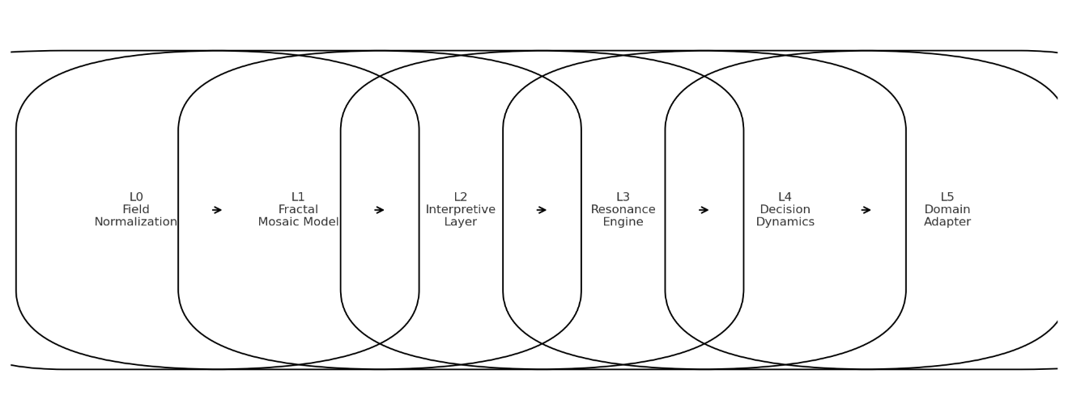

Figure 2 — Gate Segmentation Diagram
Illustrates:
- deviation threshold
- negative-space transitions
- adaptive threshold τ(t)
- fragmentation and merge conditions
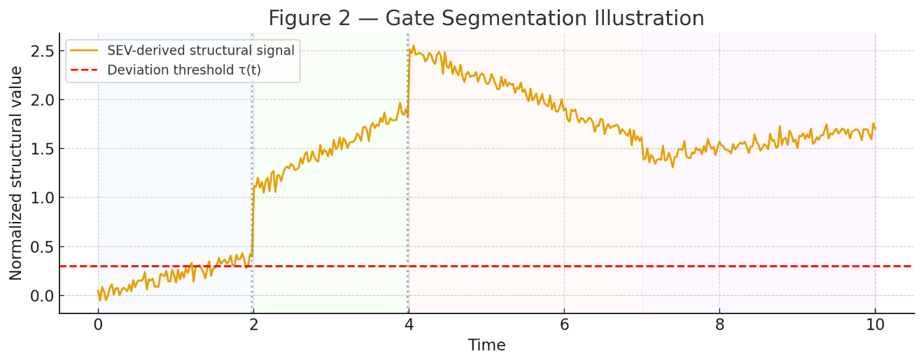

Figure 3 — Multi-Lattice Mosaic Architecture (MLMA)
Displays:
- parallel lattice projections
- consensus classification
- conflict visualization
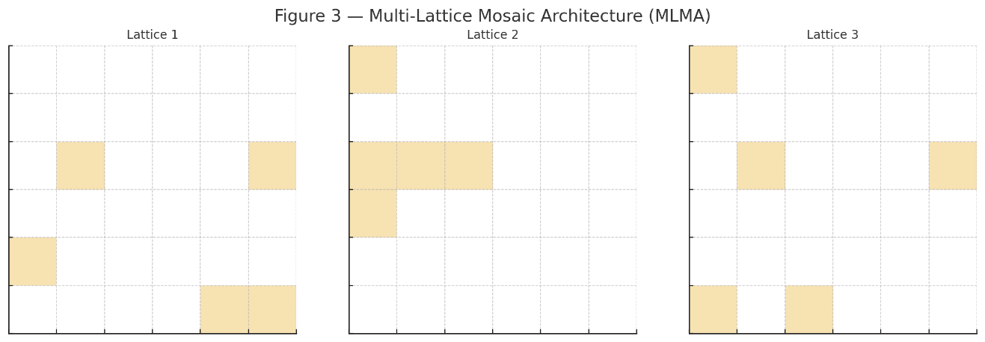

Figure 4 — Interpretive Layer Structure
Shows:
- weight contributions
- contrast vector plots
- regime identification zones
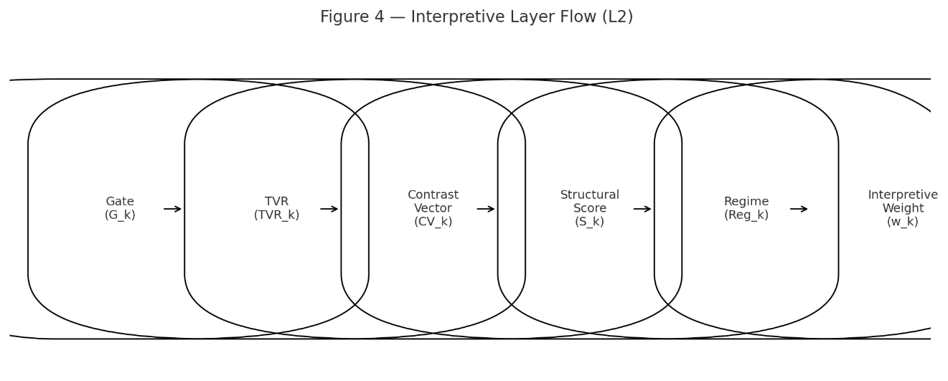

Figure 5 — Resonance Layer Structure
Depicts:
- resonance inputs (w_k, CV_k, S_k, g_k)
- coherence clusters
- temporal anchors
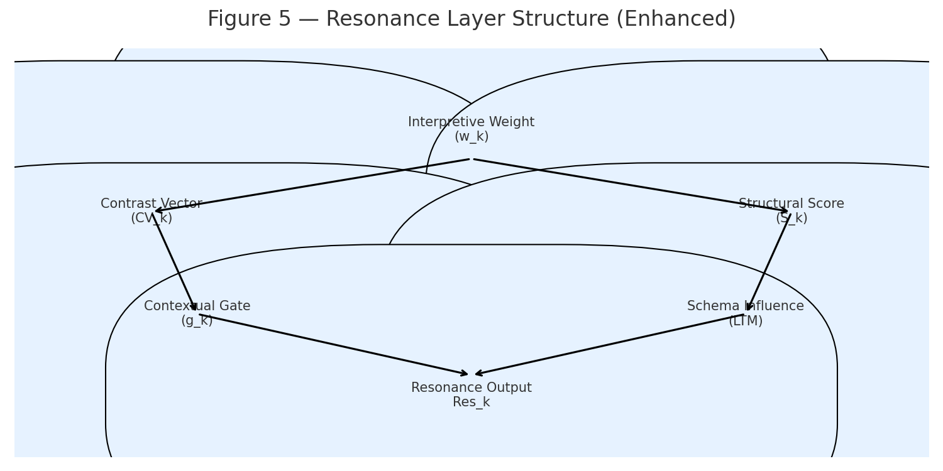

Figure 6 — Decision Surface Field (DSF)
Shows:
- directional probabilities
- reversal probability
- momentum gradient
- uncertainty correction
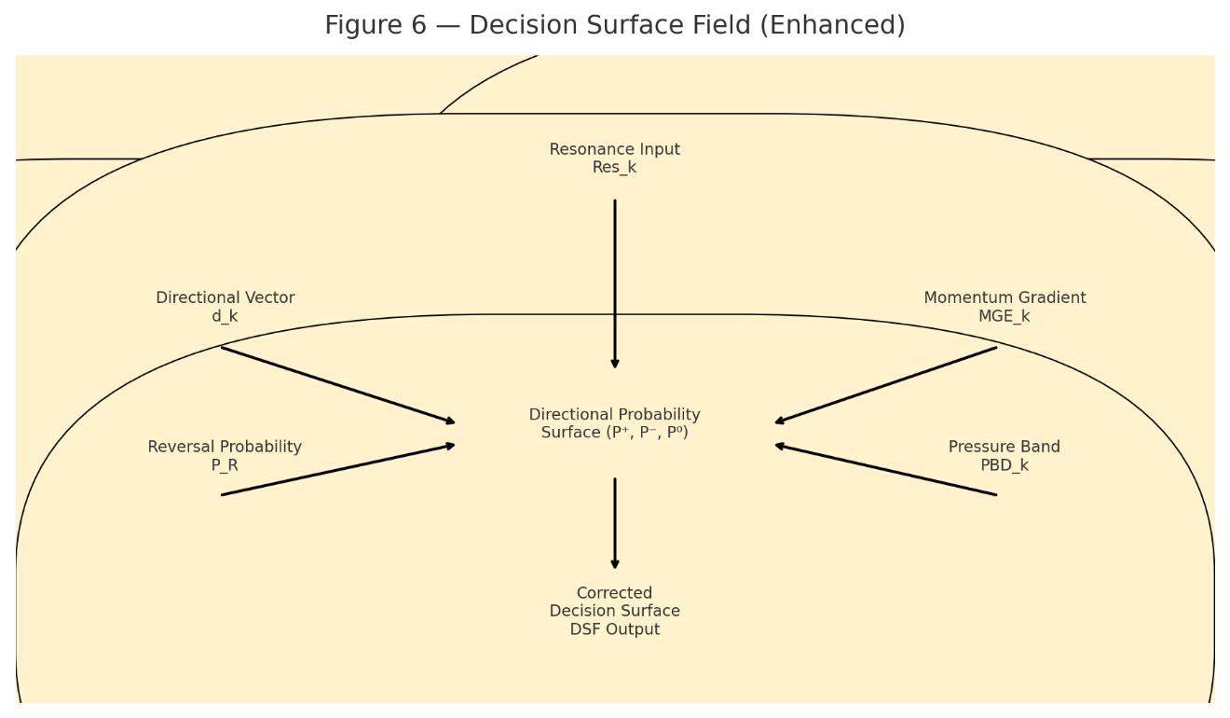

Figure 7 — G32 Cognitive Coding Diagram
Displays:
- G-unit composition
- G16 cluster
- G32 composite unit
- hierarchical scaling to G64+
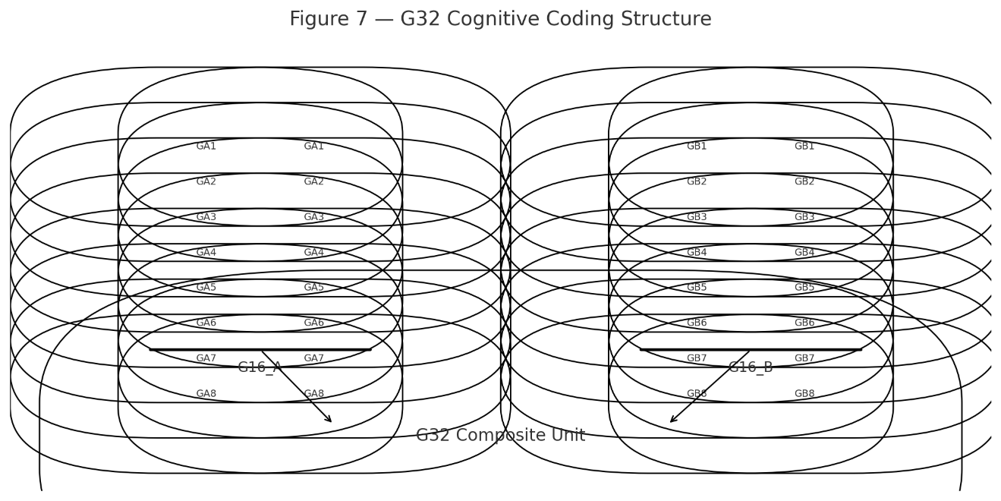

Figure 8 — Tapestry Structure
Illustrates:
- clusters
- mosaics
- URF
- schema links
- anchor positions
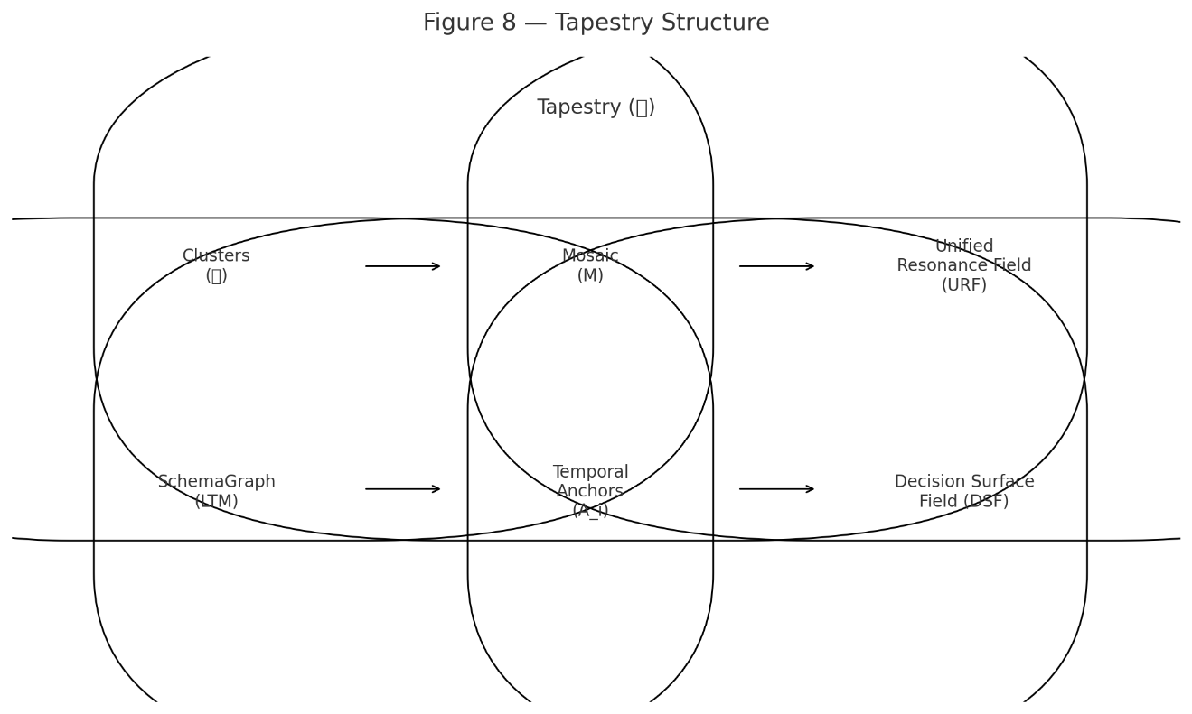

Figure 9 — Breathing Control Curve
Shows:
- expansion ξ
- contraction χ
- control variable Φ(t)
- bounded variance
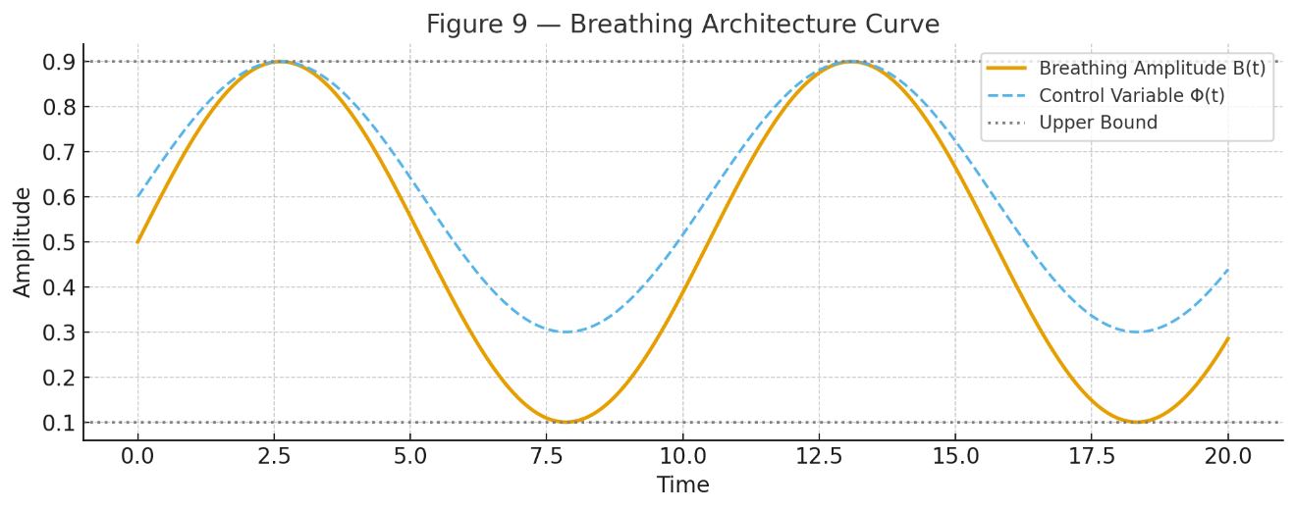

Figure 10 — Self-Organization Flowchart
Depicts:
- gate evolution
- cluster evolution
- schema evolution
- tapestry evolution
- stability constraints
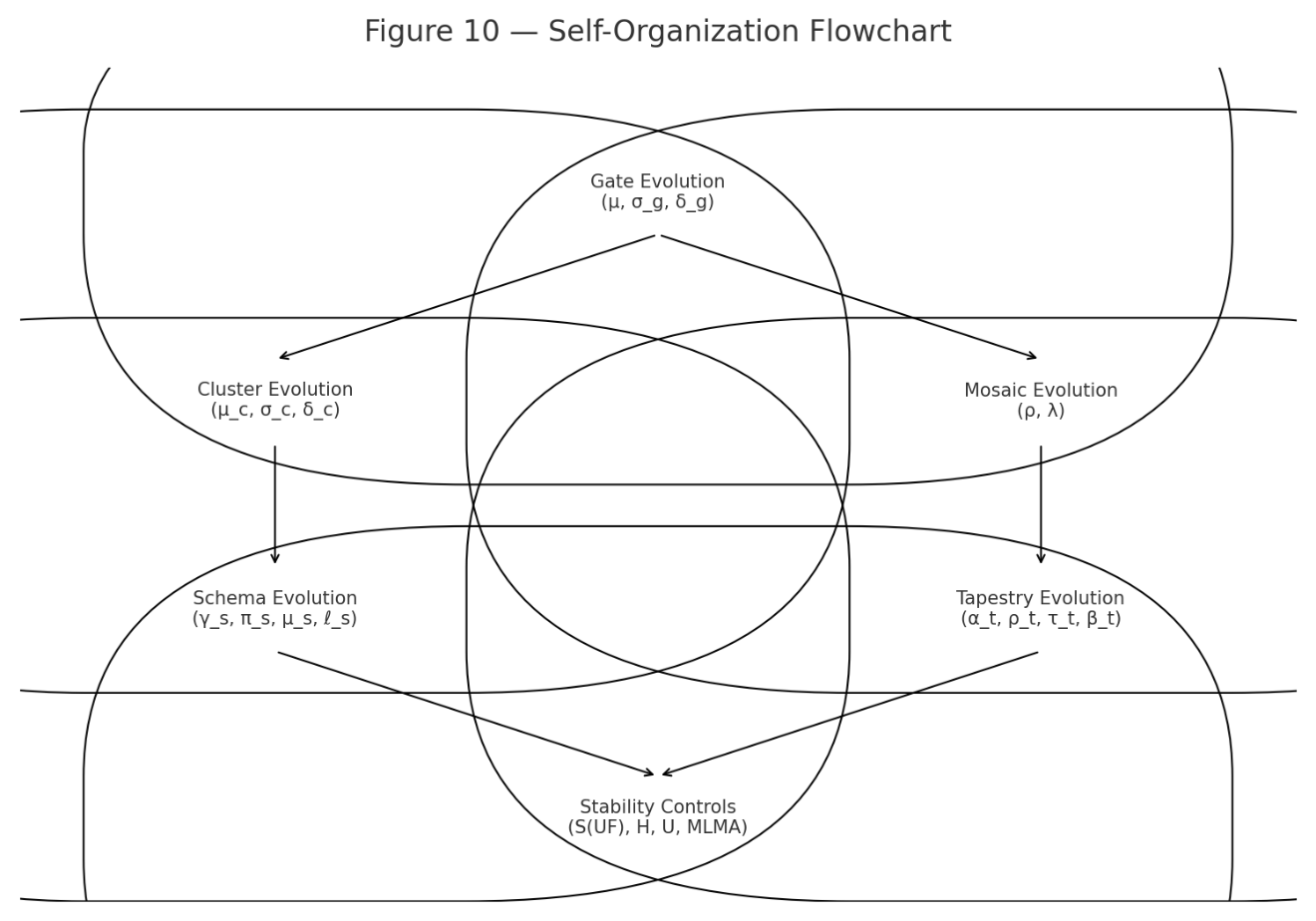

Figure 11 — Structural Encryption System (SES)
Shows:
- multi-perspective encoding
- mosaic distortion
- resonance key cryptography
- negative-space channel
- compatibility layer
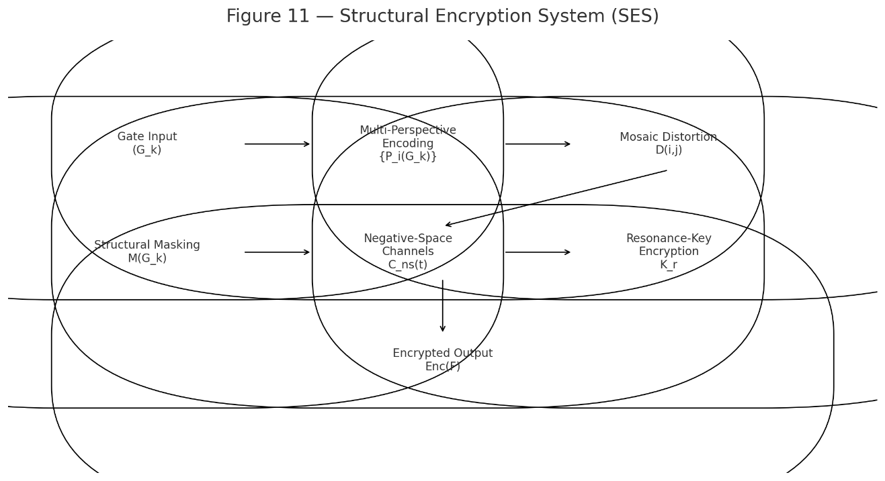

Figure 12 — Global Stability S(UF) & Robustness R(UF)
Charts:
- stability over time
- robustness under perturbation
- S(UF) threshold lines
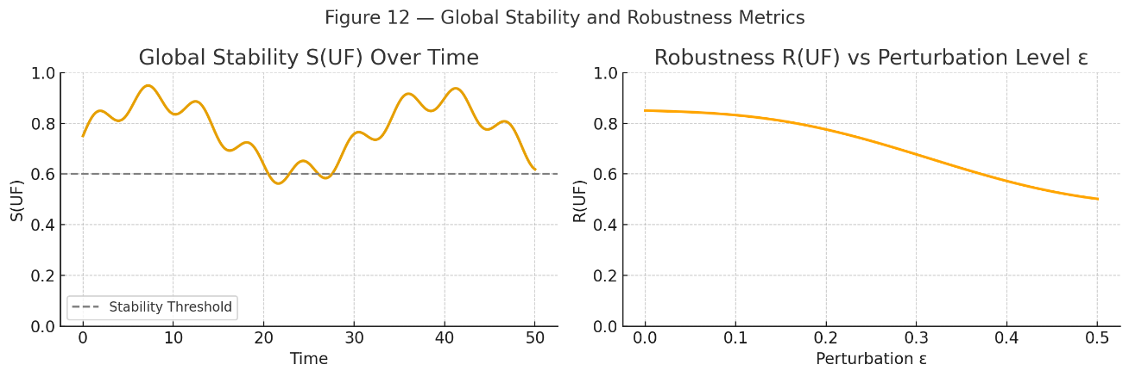

21.3 Summary
Section 21 provides visual scaffolding for UF, enabling engineers, stakeholders, and reviewers to rapidly understand the architecture.

